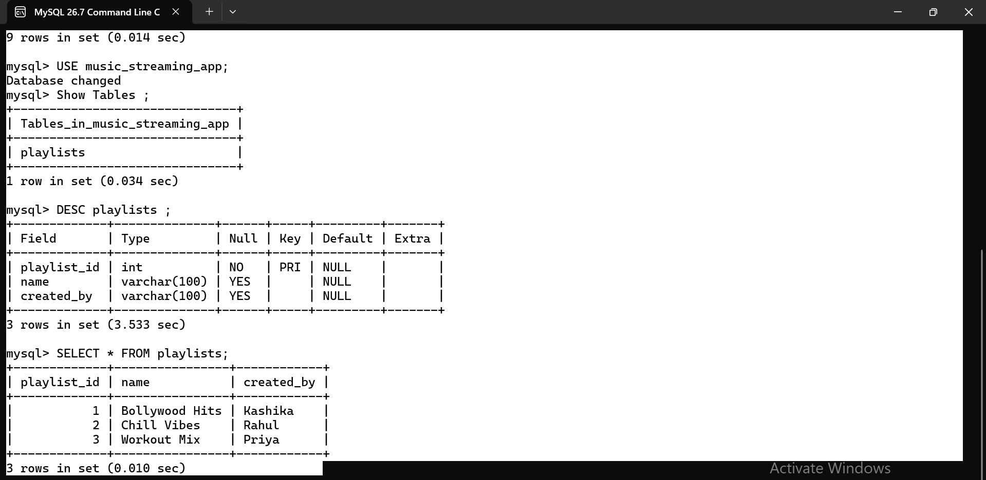
Open ChatGPT or Copilot and ask it to explain the difference between a table, a row,
and a column in SQL using an example from a food delivery app like Zomato.
Paste the explanation you receive into your assignment.
In SQL, a table is used to store related data in an organized format. A table consists of rows and columns.
For example, in a food delivery app like Zomato, an orders table can store information about customers' food orders.
order_id | customer_name | restaurant | food_item | amount | order_status
101 | Amit | Pizza Hut | Margherita Pizza | ₹450 | Delivered
102 | Priya | Domino's | Farmhouse Pizza | ₹600 | Delivered
103 | Rahul | Subway | Veg Sandwich | ₹350 | Out for Delivery
1. Table:
The entire orders table stores all the information about food orders.
2. Row:
A row represents one complete record. For example, the row with order_id = 101 contains all the details of Amit's order.
3. Column:
A column represents one type of information. For example, customer_name stores customer names, restaurant stores restaurant names, and amount stores the order amount.
In simple words:
- Table = Complete collection of data
- Row = One record/order
- Column = One category of information

